In 2024, ULI will deliver the 22nd annual ULI / Gerald D. Hines Student Urban Design Competition. The Urban Land Institute welcomes nominations from District Councils in North America for cities to host the competition in 2023. This confidential process evaluates viable cities and their associated sites.

Past Host Cities
2003 - 1st Washington DC
2004 - 2nd Pittsburgh PA
2005 - 3rd Salt Lake City UT
2006 - 4th St Louis MO
2007 - 5th Los Angeles CA
2008 - 6th Dallas TX
2009 - 7th Denver CO
2010 - 8th San Diego CA
2011 - 9th Seattle WA
2012 - 10th Houston TX
2013 - 11th Minneapolis MN
2014 - 12th Nashville TN
2015 - 13th New Orleans LA
2016 - 14th Atlanta GA
2017 - 15th Chicago IL
2018 - 16th Toronto ON
2019 - 17th Cincinnati OH
2020 – 18th Miami FL
2021 – 19th Kansas City MO
2022 – 20th Oakland CA
2023 – 21st North Charleston SC
2024 – 22nd ???

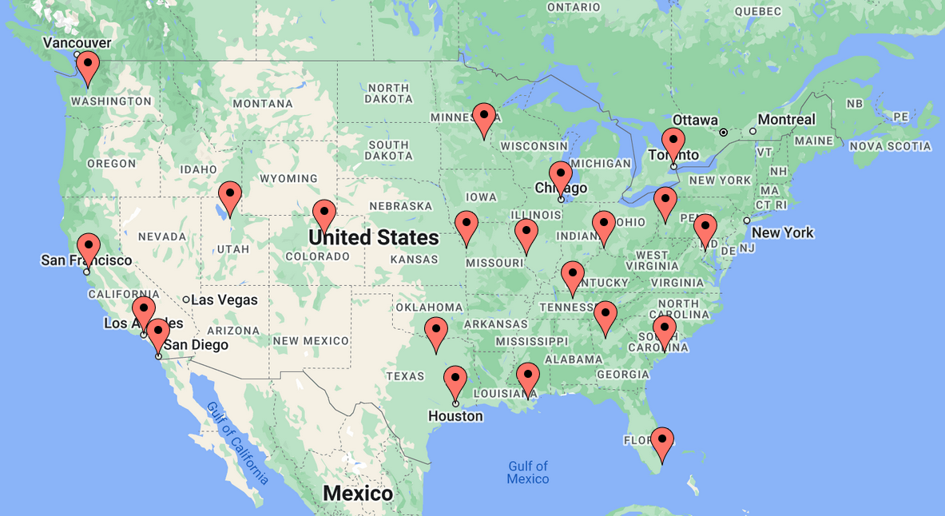

SITE SELECTION CRITERIA
- Support ULI mission and priorities
- Support competition goals: education, youth engagement, outreach, multidisciplinary practice, etc., across development, finance, planning, policy, and design (esp. architecture, landscape architecture, and urban design)
- Offer geographic diversity, new opportunities for members, and exposure of ULI’s work and best practices.
- Provide a built environment framework with development momentum, challenges, and complexities that can generate a meaningful competition brief. While the brief uses a made-up premise, and there is no intent to implement any of the proposals, the premise is based on a real development challenge and the jury considers the actual feasibility and potential impact of the students’ submissions.
- Offer strong local resources and engagement via ULI District Council, municipality, private sector, and other related organizations. Access to GIS resources, planning documentation, and local expertise is essential.
- Provide two/three potential sites for evaluation and, if pre-selected, host an informal tour for ULI before ULI makes the city and site selection.

TO SUBMIT
To submit your city for consideration please prepare a letter of interest in coordination with your ULI District Council leadership, addressing the points above. Send letters of interest to hinescompetition@uli.org with the subject line “ULI Hines Competition 2024 Host City.”

District Council Responsibilities for Competition

- Engage local government and development community to find a site suitable for the competition
  - 10-30 acre site (approximately)
  - Appropriate for mixed-use urban development
  - Market analysis generally supports substantive development in phases over a 10 year period
  - Has not already been planned or designed for ad nauseum
  - Privately or publicly-owned
  - Owner approval - even though it is an ideas competition, we need all parcel owners’ approval to require the students to design for the parcel; we can suggest students identify parcels adjacent to the main development site that might be worth including in their proposal without owner approval; but we won’t require the students to include any parcel in their proposal unless we have its owner’s signoff)
  - Nice to haves:
    - Redevelopment site
    - Adjacent to water body or large institutional or public use
    - Interesting transportation challenges welcome
    - Equity, affordability, resiliency, or sustainability challenges
- Support logistics
  - Help identifying best hotels, presentation venues
  - Coordination of local ULI members
- Engage ULI members and local government staff to:
  - Form part of the Main Jury
    - We need 4 of 12 jurors to be from the local market (city/region). Expertise across three disciplines is key: 1. Design (architecture, landscape architecture, urban design), 2. Finance, 3. Planning/Economic Development. Demographic diversity is ideal. The main jury meets once in February in D.C., and again in the host city in April to judge the finals.
  - Form the Rehearsal Advisors group
    - We need 6 of 6 jurors to form a group to watch the students’ rehearsal presentations and provide feedback; diversity of expertise and demographics is key, as with main jury.
  - Host 3-4 site tours
    - Staff (Sept/Oct)
    - Students (March)
    - Jury (December and/or April)
  - Provide local files and planning documents
    - GIS files
    - PUD planning documents
  - Support staff or a contractor writing the 25- to 35-page Challenge Brief:
    - Advise on how to shape the challenge
    - Read and suggest edits/corrections
    - Provide local assumptions (construction costs, market analysis)
  - Be available during the competition to answer questions the teams might have that the challenge brief does not address
  - Attend the finals, which should be free and open to the public
- (Optional) Host a breakfast/luncheon and/or reception the evening of the finals for ULI members

