ULI Mission: Shape the future of the built environment for transformative impact in communities worldwide
CONNECT active, passionate, diverse members through the foremost global network of interdisciplinary professionals
INSPIRE best practices for equitable and sustainable land use through content, education, convening, mentoring, and knowledge sharing
LEAD in solving community and real estate challenges through applied collective global experience and philanthropic engagement

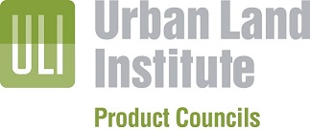

[Council Name] Agenda

Chair: Phone: Email:
Assistant Chair: Phone: Email:
Membership Vice Chair: Phone: Email:
Vice Chair: Phone: Email:
Vice Chair: Phone: Email:

Council Dinner/Reception – April 20th, 2022

Location:
Address:
Time:
Transportation:
RSVP and cost:

Council Day Agenda – April 21st, 2022
Location – TBD, San Diego, CA

7:30-8:00 Networking Breakfast

8:00-8:30 Chair’s Welcoming Remarks/Introductions/General Announcements/Business Session

- Introduction of Members and Guests
- Reminder to Complete Attendance Sheet
- Reminder to Complete Evaluation Form
- ULIF Announcement, new video available
- Review of ULI Priorities & Council Member Expectations (see back page of your agenda)
- Discussion re: Suggestions for Future Council and Concurrent Meeting Programs
- Announce Next Meeting:
- ULI Fall Meeting 2022 – Dallas, TX
- Receptions on Tuesday, October 25th, 2022
- Council Meetings on Wednesday, October 26th, 2022

8:30-X:00 1st Session Title
Description

(Please use the following format for Moderators/Speakers/Panelists)

Moderator:
Full Name (See key below)
Title
City, State

Speaker(s):
Full Name (see key below)
Title
City, State

4:00-5:00 General Session

5:00-6:00 Closing Reception

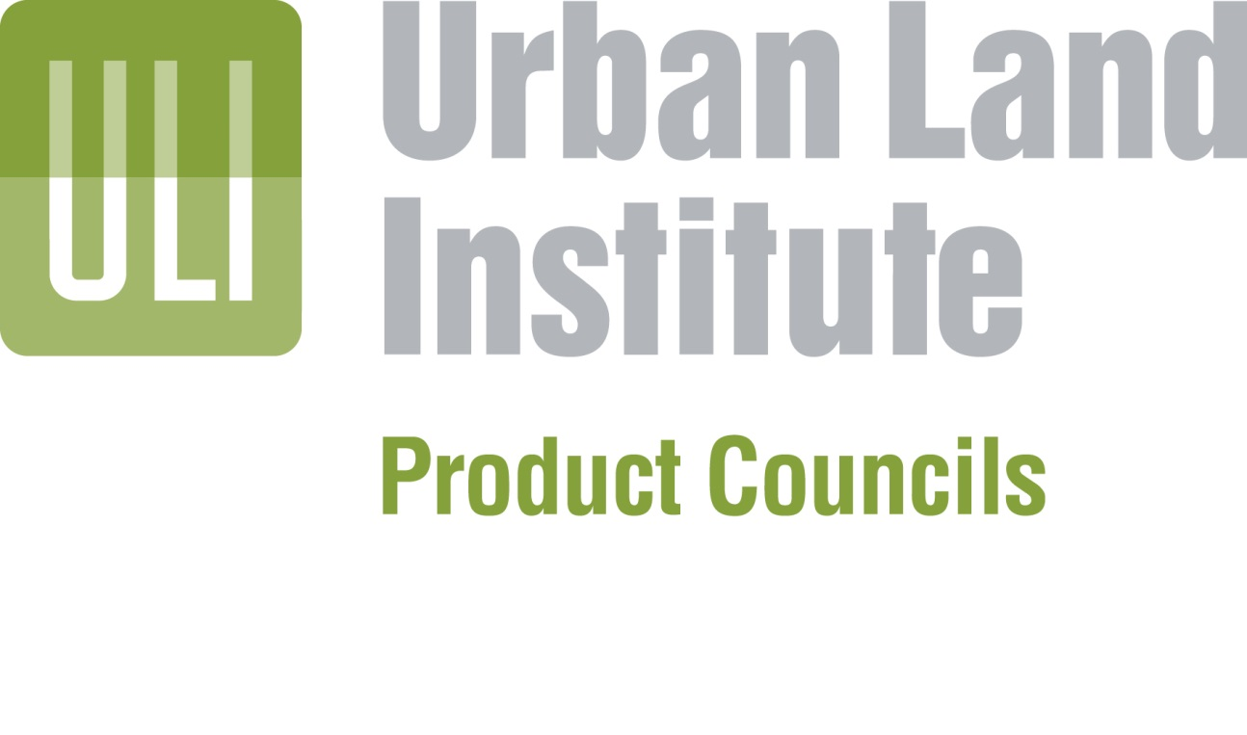

ULI’s Priorities

- Promoting Intelligent Densification and Urbanization
  - What are the most responsible ways to provide cost-effective housing for a rapidly increasing global population that is becoming increasingly urbanized?
  - How can we advance the understanding of the relationship between a high-quality of life and the built environment to create high-quality, appropriately-priced density that is attractive to users?
  - What is the relationship between a thriving economy and a thriving city (and vice versa)-the relationship between a dynamic society and the built environment?
- Creating Resilient Communities
  - What are the best new business models in the real estate and land use industry and how can we support their development?
  - How can we best adapt and reuse existing real estate while eliminating obsolete space to create thriving communities?
  - How can we influence land use leaders locally and around the world as they reshape the process of community building and developing both social and physical infrastructure?
- Understanding Demand and Market Forces
  - How can we best understand the demand (quantity, type, price, and location of the need) for real estate and discover what the market wants short-term versus what the market needs long-term
  - How can we help balance local, regional, national, and global interests as well as public and private interests in terms of how they affect land use decisions and development?
  - How will changing technology influence building and buildings, and how will people’s use of technology influence how they interact with the physical environment?
- Connecting Capital and Real Estate Through Value
  - How can we best generate value in the built environment that is greater than its cost?
  - What are the best ways to ensure the attractiveness of real estate as an investment as institutional capital allocators continue to change and become more global?
  - What is the most effective way to demonstrate and explain the relationship between investment in public projects and amenities and the impact on real estate value?
- Integrating Energy, Resources, and Uses
  - How can we best reduce the negative impact of the built environment on our natural resources and climate?
  - What are the best ways to use the world’s energy resources and protect the built environment from volatile and unpredictable conditions?
  - How will trends in energy and resources impact the future best use of land?
ULI Council Member Expectations

Council membership is a privilege desired by many ULI members and the value of the Council experience is determined by the quality and participation of its members. Each Council member is therefore expected to be a committed and participating part of the Council, contributing as much value to the Council experience as they take home.

OPEN, HONEST, SPECIFIC INFORMATION AND EXPERIENCE: Come to Council meetings ready to participate openly and honestly with specific, detailed information and experience from your current real estate practice.

CONFIDENTIALITY: Everything discussed within a Council is kept completely confidential by all Council members. This is the foundation that makes open and honest sharing of detailed information and experience possible. Violation of confidentiality will result in immediate expulsion from your Council.

REAL DEALS, REAL NUMBERS: The key to truly valuable interaction between the Council members is the sharing of real deals and real number, successes as well as lesson learned.

RESPECT FOR OTHERS: Help make discussions productive and high value by engaging your fellow council members respectfully with your most relevant information and experience.

NO SELF PROMOTION: Councils members are all highly successful real estate professionals. Self promotion and pitching do not add value for your fellow council members. Keep your presentations and discussions aimed at delivering real take home value for your peers, not your business.

NO CELL PHONES OR BLACKBERRIES: It should go without saying that you cannot be fully engaged in your council while checking your email. Most Councils have breaks designed to allow members to check in and stay connected a few times during the day.

ATTEND EVERY MEETING AND ATTEND ALL DAY: Each Council member has been chosen for the value that their unique background and experience brings to the Council. Missing a Council meeting or part of a Council meeting reduces the value for every other member of your Council. Your empty seat could easily be filled by someone else who has value to bring to the table.

RECRUIT THE BEST AND BRIGHTEST: Council members often come into contact with new leaders in the industry, ULI members and non-ULI members, with exciting new products, ideas and best practices that will add greatly to the value of their Council. Bring these new leaders as guests to your Council, sponsor them for Council membership and work with your Council leadership to help them become future members of your Council.

PARTICIPATE IN ULI AND ULI LEADERSHIP: Council members are expected to be active participants in ULI’s mission of providing leadership in the responsible use of land and in creating and sustaining thriving communities worldwide. Your involvement in ULI provides excellent opportunities to network and to learn both within and beyond the boundaries of your industry segment:

- Attend and participate as speakers and panelists at ULI Spring Council Forums and Fall Meetings.
- Attend and participate as speakers and panelists at Council meetings.
- Serve as panelists at Project Analysis Sessions held at Spring Council Forums and Fall Meetings.
- Serve as panel members for Advisory Services assignments scheduled throughout the year.
- Contribute to ULI publications through the contribution of articles and papers.
- Contribute to the ULI Foundation.
- Participate as Committee/Subcommittee/Task Force members.
- Participate in research and education programs.
- Participate in District Council programs in each member’s area.

